Assignment 1: Part 2 – Hosting a Static web page using AWS EC2 instance

For this assignment, I must create a static web page and mention my name on it.

So, I will be using an AWS EC2 Linux instance and apache web server to host the test html site that I created. So, the steps are as follows:

1. First, I must create an EC2 instance. So, I logged into my AWS console and went to EC2 services. Then, I selected launch instance chose Linux AMI. Further, I used all the default settings.

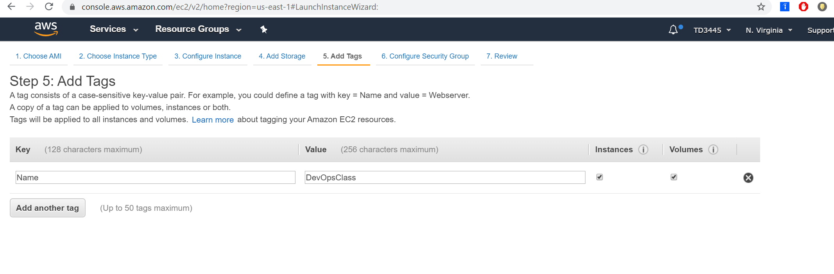

1. I decided to choose my existing security group (TestSiteDemo) which has unrestricted access to HTTP, HTTPS and SSH ports.

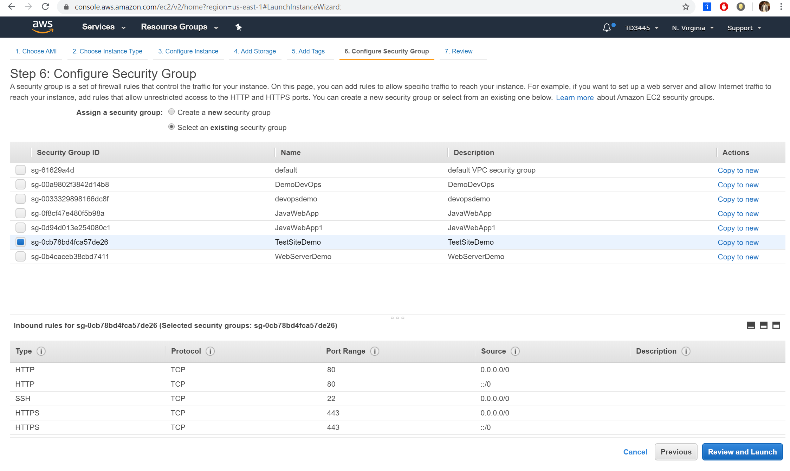

1. The next step was to review whether all the settings were selected appropriately or not and choose the key pair, I decided to go with the existing one (TestSiteDemo1).

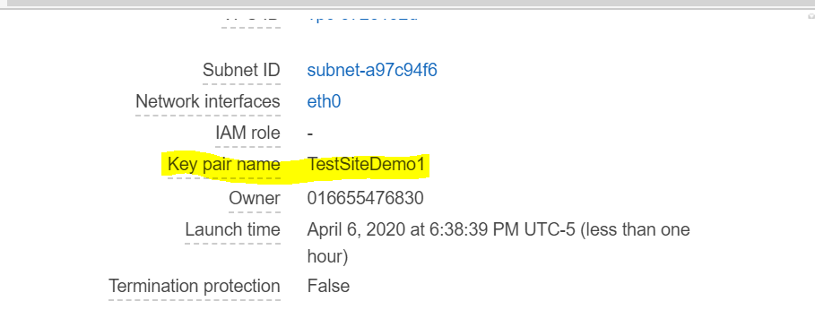

1. Then, I launched the EC2 instance.

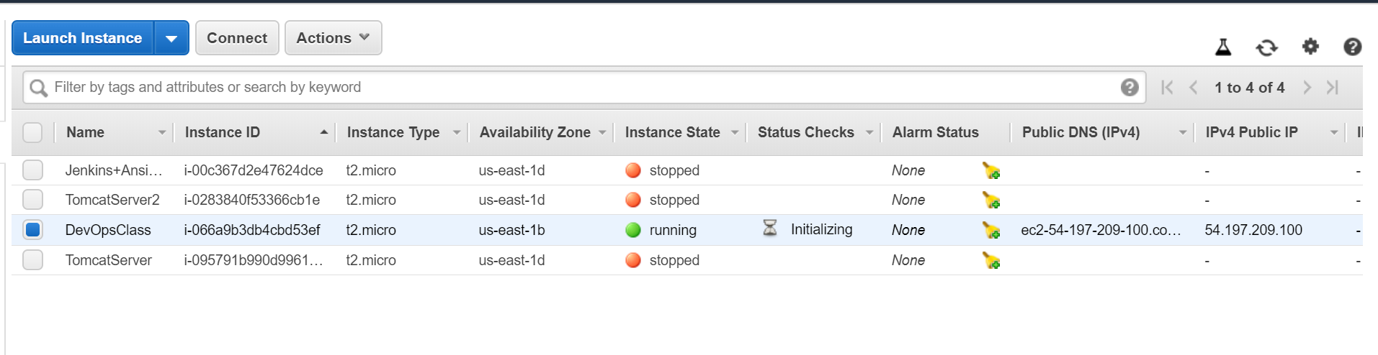

1. I will be using putty to SSH into the EC2 instance. For this, we need the public IP address of the server and the key pair. First, I must enter the IP address.

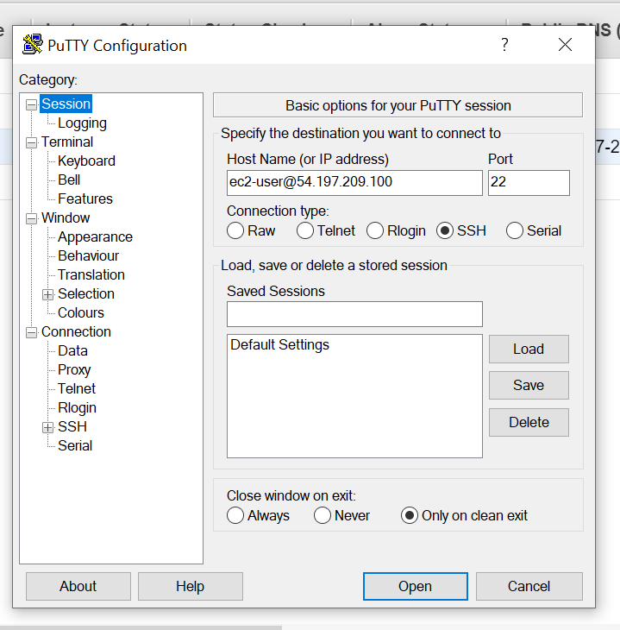

1. Second, I must select the key pair to authenticate and then ssh into the server.

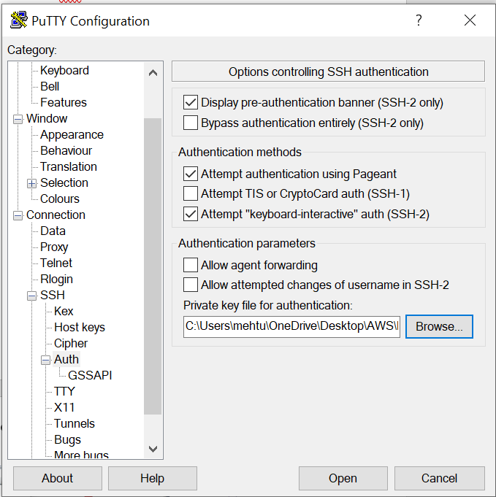

1. After the successful connection, we need to use the cmd “sudo yum update -y”to update the packages and use the latest versions of linux.

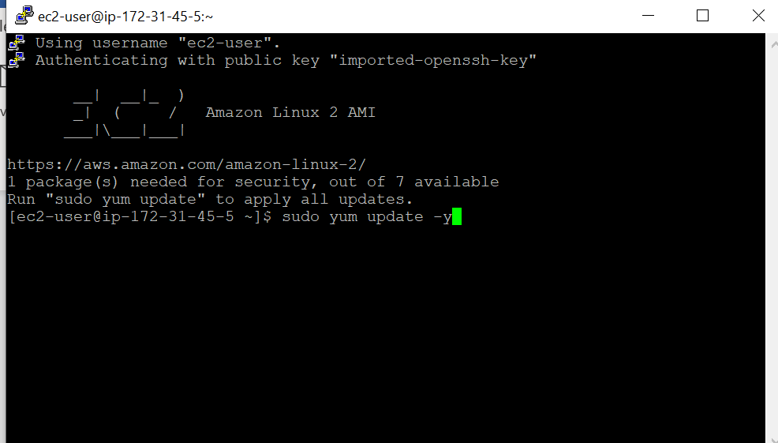

1. The next step is to install apache web server into our linux instance to host the web page. For that we need to use the cmd “sudo yum install httpd” and ‘-y’ is for the ‘yes’ to complete the installation.

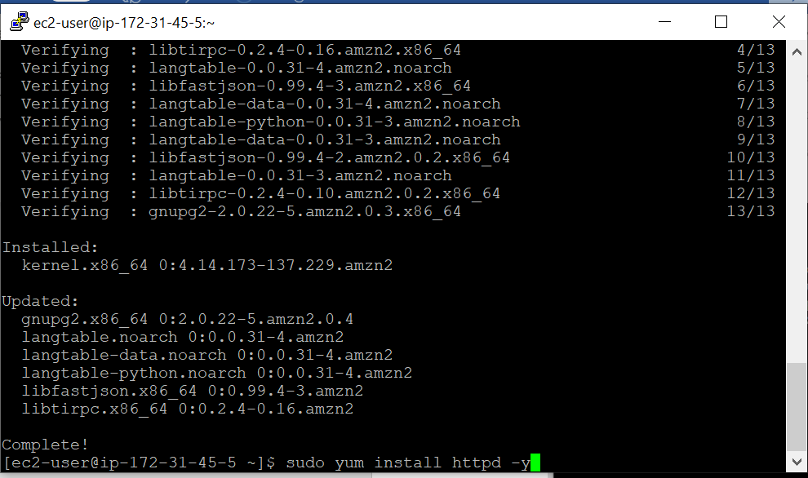

1. Since we have already installed the apache server, we need to start it. Hence the cmd is “sudo service httpd start”.

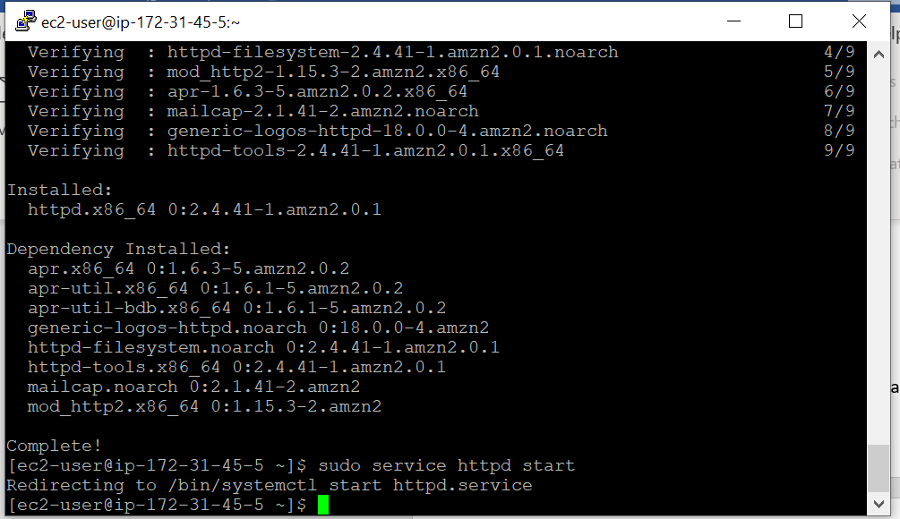

1. Now, we must check the status of the service whether it is active or not. Hence the cmd is “sudo service httpd status” and it shows that the status is active.

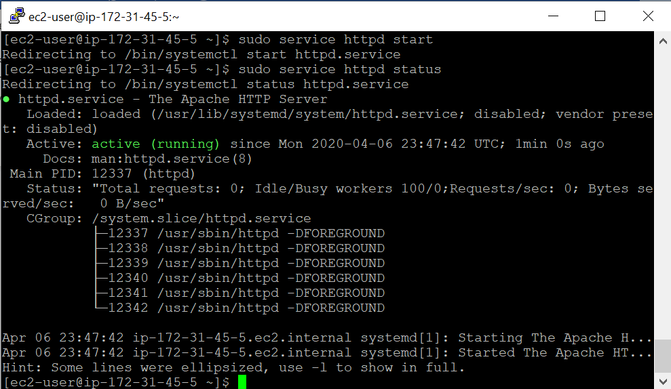

1. Next, I used the same IP address of my EC2 instance and copied it on the browser to check if it gives me a test page and see if the apache http server was installed successfully. It gave me the following test page and mentioned the directory where need to put our file to view on the webpage. Next, we need to create the directory “/var/www/html/”.

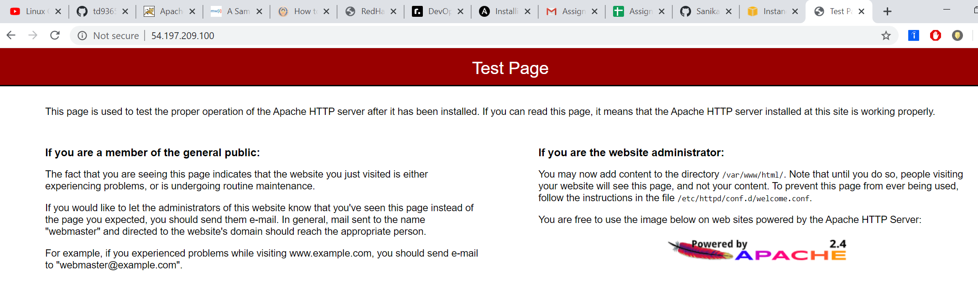

1. In the next step, I created the above-mentioned directory using the cmd “cd /var/www/html/”. 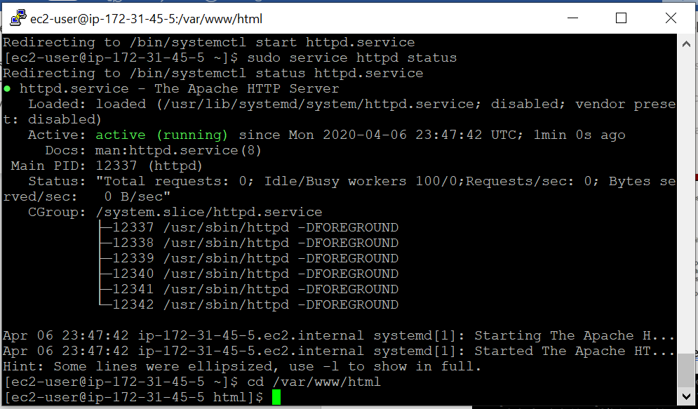
2. Now, I need to create the index.html file inside the directory in order to view it or I can use the same testSite.html link from the AWS S3 bucket and copy it in “cd /var/www/html/ “ directory. So, I decided to go with the second option. I used the command “sudo wget <https://myawsbucket19950831.s3.amazonaws.com/testSite.html>”, where wget is used to download/copy file into the /var/www/html/ directory.

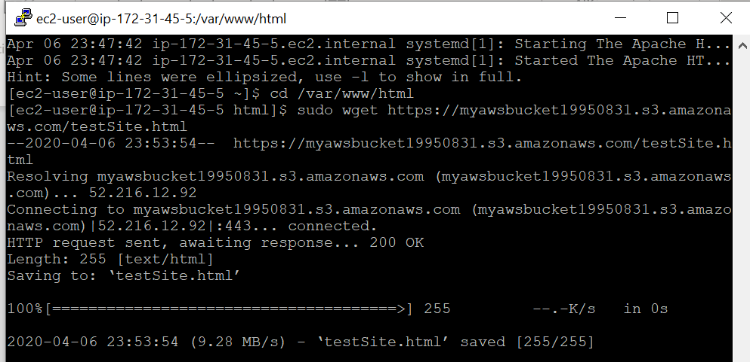

1. The testSite.html file can be accessed by first going to the folder i.e “cd /var/www/html/ “ and then use the cmd “ll” to list the files inside that folder. 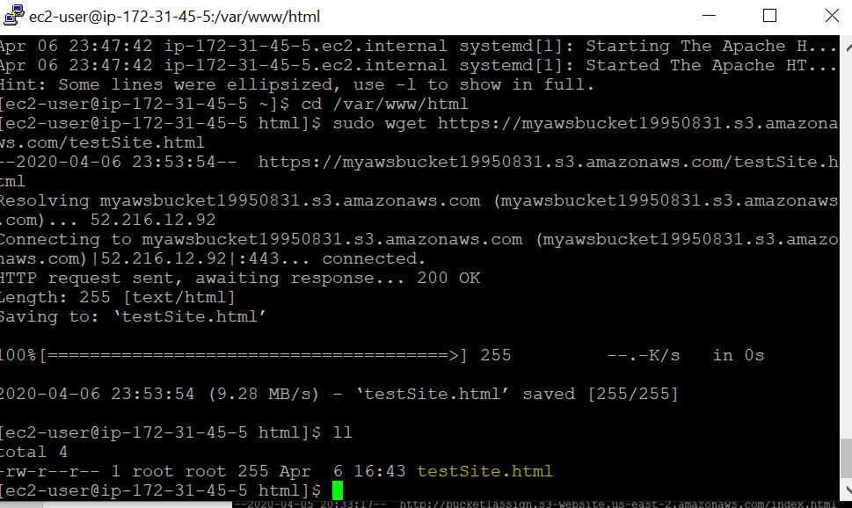
2. The file is finally created and copied in the specified directory. In order to access the website, we need to use the Ip address of the EC2 instance and /testSite.html. This will render the “testSite.html” web page.

